West Wales Regional Athletics Council – Friday 12th December
Canolfan Gwili, Hendy / Microsoft Teams

Attendees:
Rob Campion (Chairman), Nathan Jones (Secretary), Les Cuthbert (Treasurer), Andrew Jenkins (Afan Nedd Tawe Schools Association), Lisa Campion (Track and Field Committee Representative), Steve Hames (Welfare Officer), Owain Schiavone (FMR Committee Representative), Dee Jolly (Sarn Helen)

Apologies:
Jennifer Boyce, Nigel Jones, Aled Jones-Davies, Gareth Harries, Kevin Tobin

Actions from last meeting:
None

Discussion:
West Wales Indoor Championships – January 31 / February 14: Track booked, first aid booked, photofinish booked, refreshments booked. Microsoft form to be sent to officials to get their availability and to avoid officials travelling to the winter throws. Entries to open on December 27 (number of events have sold out early for opens in Cardiff, opening entries a month out will give everyone an opportunity to enter and are likely to turn up) £6 an event.

West Wales 200m, 300m, 400m and Race walks Indoor Championships: December 7, generally low turnout from West Wales athletes despite having more podium finishes this year. 800m and 1500m championships in January will be a regional indoor championships.

Welsh Inter-Regional in Newtown: West Wales held their championships at Margam Park last weekend. Juniors up to under 15 were well attended, unfortunately under 17 men / under 20 / seniors and masters uptake was low. Some athletes possibly choosing other events off-track which happens at the same time of year.

UK Inter-Counties Cross Country Championships in Nottingham: Selection agreed: Top 8 juniors from the Welsh Inter-Regionals. Expression of interest for Under 20, Seniors and Masters.

Club Modernisation and Development Grant: now open for clubs and deadline is Saturday 31 January.

West Wales Junior Open for summer 2026: five possible dates sent over by Euan Coney when junior leagues could happen in the summer for U12, U14, U16 age groups. 16th/17th May, 20th/21st June, 8th August (Neath / Brecon / Carmarthen likely to be locations, to be made official by next meeting). All clubs taking part will need to provide a track judge, timekeeper and field judge as previously discussed to avoid potential issues similar to last year.

Information:
Reports
General Council: Lack of interest from schools in athletics, promoting school events through the clubs should be encouraged. Regional grants discussed and additional supported requested from WA. Not enough sign ups for official courses, resulting in cancellations.
Track and Field Committee: Recent meeting was cancelled.
Officials: Slow uptake for officials courses, endurance courses in the South will be unavailable for a while new tutor is found.
Road Running/Cross Country Committee: No update.
FMR Committee: GB uphill only trial is in Keswick on Friday 1st May
British Inter Counties will be at Sedbergh on Monday 3rd May. They're keen for us to have a West Wales team competing here so it would be good to have a callout for expressions of interest.
Snowdon International race - the trial race for the Wales team in this will be Ras y Gader (Cader Idris) which is 16th May 2026.
Welsh Inter Regionals is very likely to be Cilcain Mountain Race (Clwydian Range) which is usually August Bank Holiday Monday. Difficult to get a West Wales team as it's bank holiday and a bit of a trek for us from the far West. Expression of interest to be communicated.
The Silver Trail Half Marathon (Nant yr Arian near Aberystwyth) will once again be Welsh Short Course Trail Championships in 2026, having filled the gap left by the Red Kite Challenge in 2025.
Discussions on going about the Long Course Championships with a few options on the table, but it's up for grabs if anyone has a West Walian race suggestion (ideally needs to be 50k with a fair bit of elevation, 5000ft+ may
Decided to continue with the Nant yr Arian Silver Trail Half Marathon 2026 as the “short” trail running championships. Could be the West Wales championships in March?
Welfare Officer: Nothing to update

Finance report
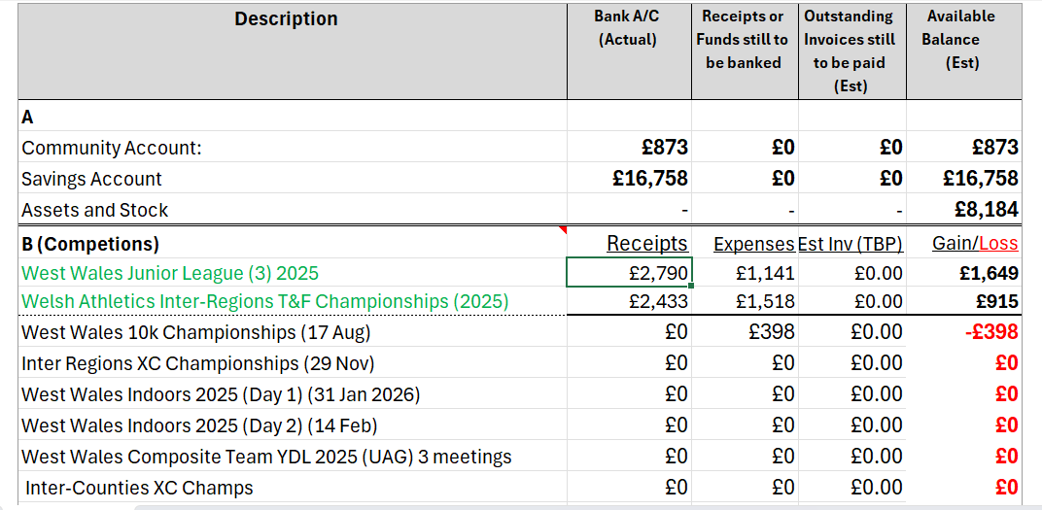
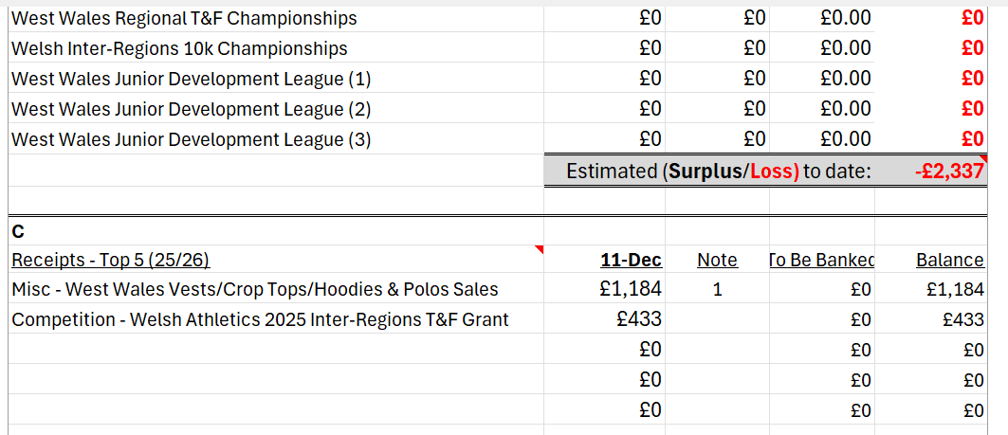
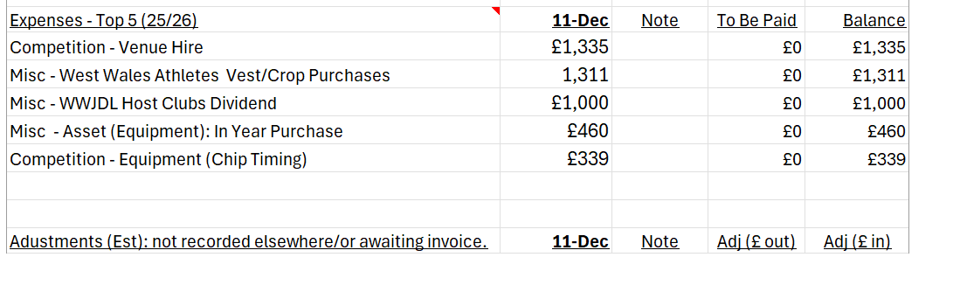
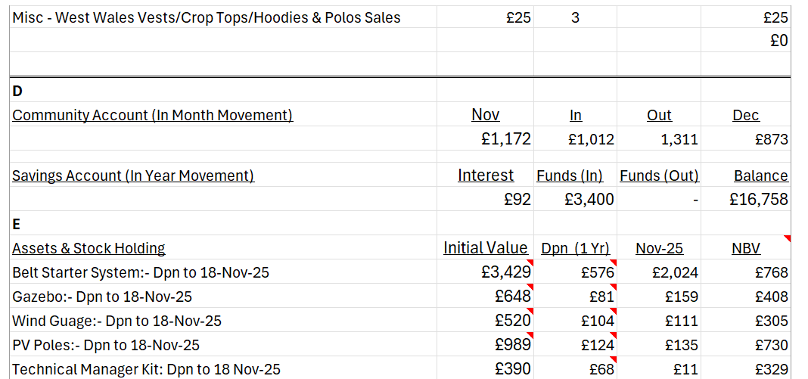
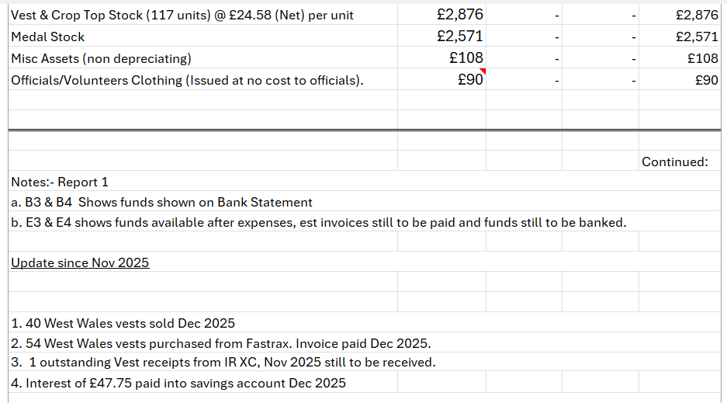

Any Other Business:
Look into introducing a regional council website.
West Wales Tent – one of the legs to be looked at following Newtown, receipt for parts has been sent. Another 3 x 3 to purchase to increase space for regional events?

Date of Next Meeting:
Friday 6th February 6:30pm.

